**ASSIGNMENTS ON DIGITAL MARKETING**

**NAME:** ARULARASU.S

**DEPARTMENT:** B.E (ELECTRONICS AND COMMUNICATION ENGINEERING)

**COLLEGE:** 8151 DHANALAKSHMI SRINIVASAN INSTITUTE OF TECHNOLOGY

**NAAN MUDHALVAN COURSE:** DIGITAL MARKETING

**NM ID:** 1922CA7DFBAAA6787B840DCD6B4632A6

**ASSIGNMENT 1:**

Create a blog or website using Blogspot and Wordpress. Customize the theme design and post new article with 500 words.

<https://alocruisetravels.wordpress.com/2023/10/19/alo-cruise-travels/>

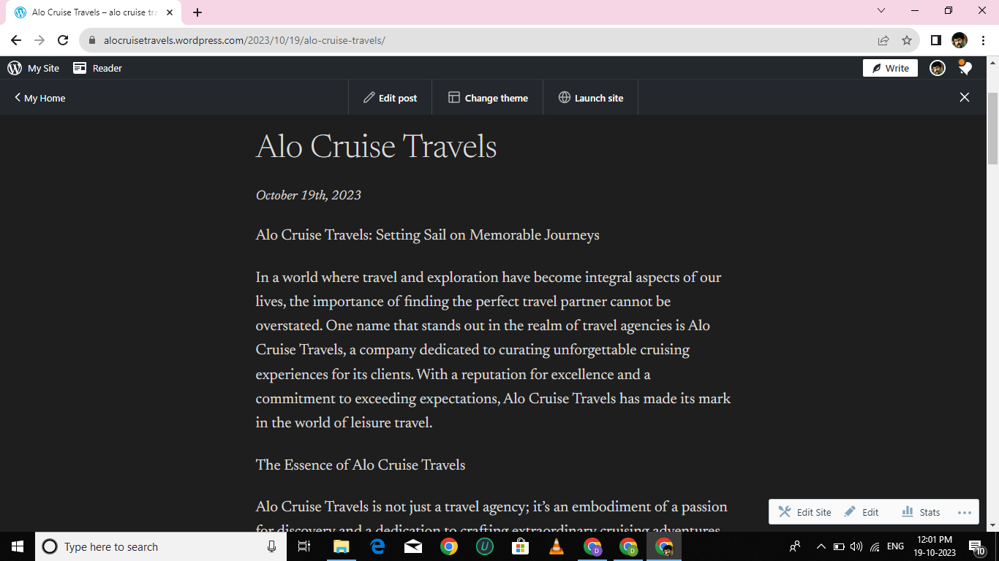

**ASSIGNMENT 2:**

Create a new Facebook business page and post one social media poster for your brand.

<https://www.facebook.com/profile.php?id=61550794191716>

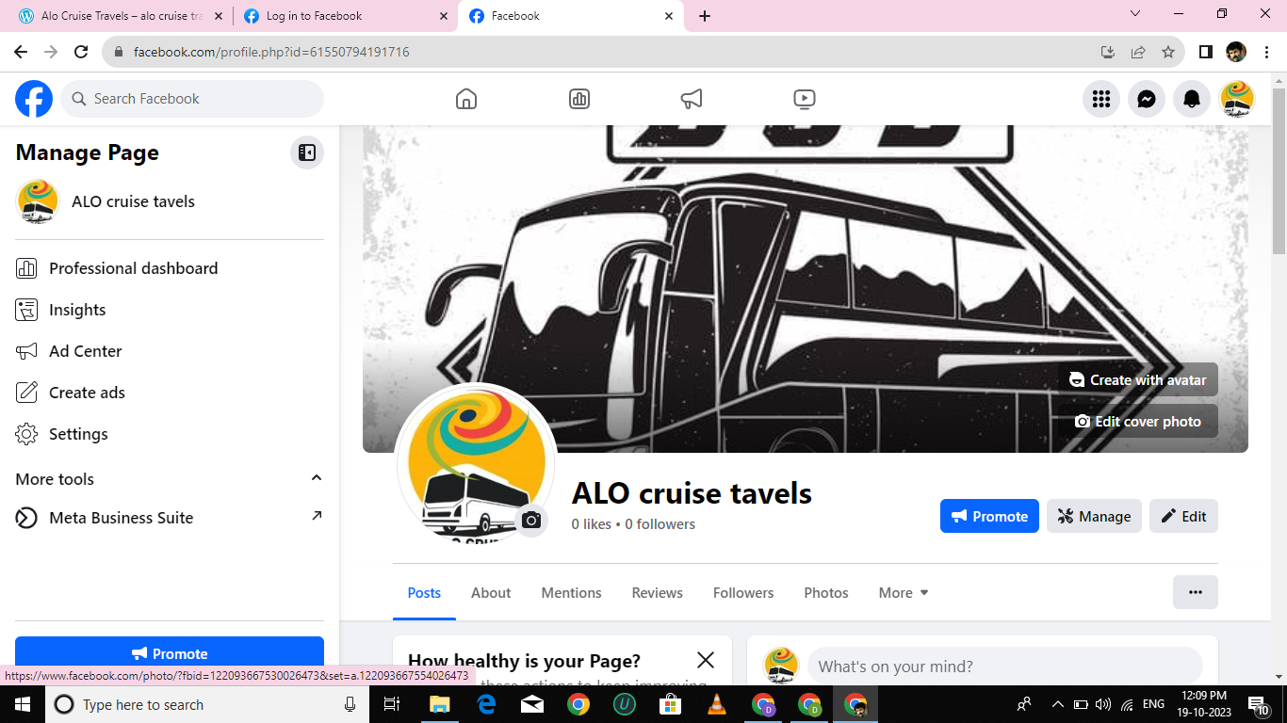

**ASSIGNMENT 3:**

Create and design a social media advertisement poster using canva.

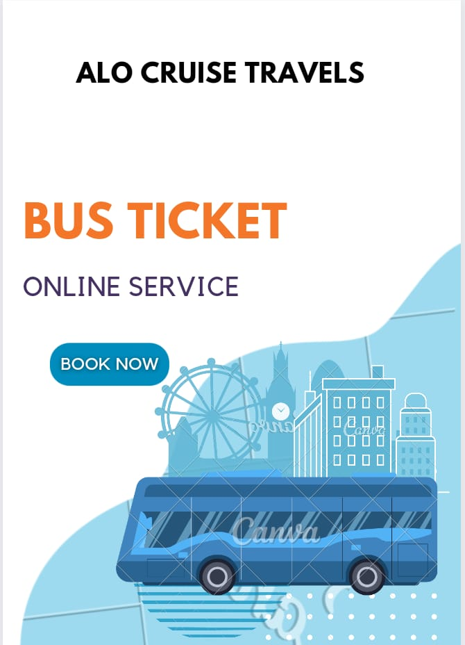

**ASSIGNMENT 4:**

Create email newsletter design using Mailchimp or Canva.

